**What’s Your Estate Plan???**

***Presented by****:**David Skaggs, J.P. Morgan Client Advisor (St. Monica Parishioner) and Jack Challis,Trust Officer, Midwest Trust*

**Topics to be discussed include:**

* **Planning for Incapacity**
* **Avoidance of Probate**
* **Planning for Proper Disposition of Estate**
* **Creditor Protection**
* **Passing on a Legacy of your Values through an Ethical Will**

September 13, 2017

7:00 pm - 8:30 pm

St. Monica’s Church Meeting Room

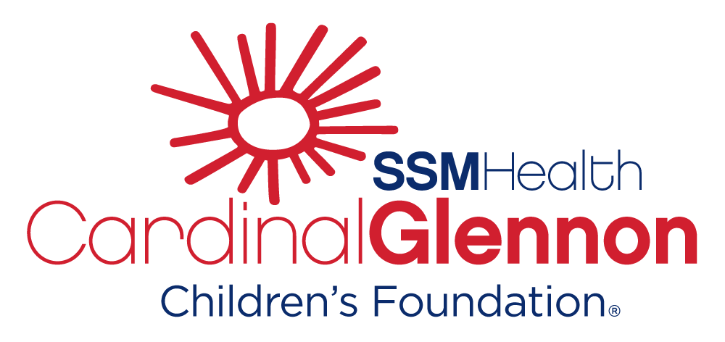

**Sponsored by**:

**To RSVP please contact**:

Rose Brower at [rose.brower@ssmhealth.com](mailto:rose.brower@ssmhealth.com) or call 314-577-5605.